1. Agenda:
   1. Overriding the default configuration.
2. Changing port and context.
3. 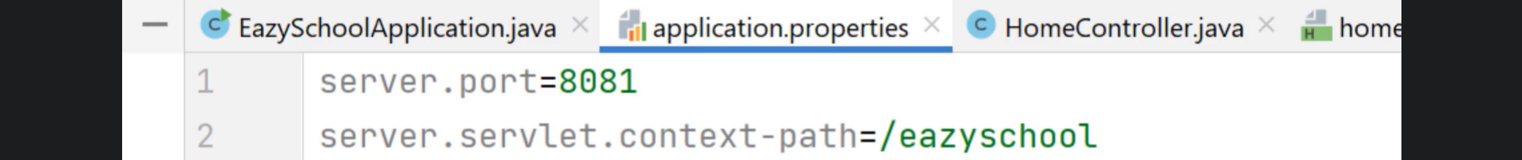
4. 
5. 